**Uncovering Insights in the Titanic Dataset using Exploratory Data Analysis**

**Example Dataset** :“Titanic: Machine Learning from Disaster" from Kaggle.  
  
**Objective:**

* Understand the factors that affect the survival rate on the Titanic.
* Perform data cleaning and preprocessing.
* Visualize data to identify patterns and relationships.
* Derive meaningful insights from the analysis.

### **Introduction**

The Titanic dataset provides information on the passengers aboard the RMS Titanic, which sank in 1912. This analysis aims to explore the factors influencing the survival rates of passengers using various exploratory data analysis (EDA) techniques.

**Dataset Description**

* The dataset includes the following attributes:
* PassengerId: Unique ID for each passenger.
* Survived: Survival status (0 = No, 1 = Yes).
* Pclass: Ticket class (1 = 1st, 2 = 2nd, 3 = 3rd).
* Name: Name of the passenger.
* Sex: Gender of the passenger.
* Age: Age of the passenger.
* SibSp: Number of siblings/spouses aboard.
* Parch: Number of parents/children aboard.
* Ticket: Ticket number.
* Fare: Passenger fare.
* Cabin: Cabin number.
* Embarked: Port of embarkation (C = Cherbourg, Q = Queenstown, S = Southampton).

**Exploratory Data Analysis:**

Load the data  
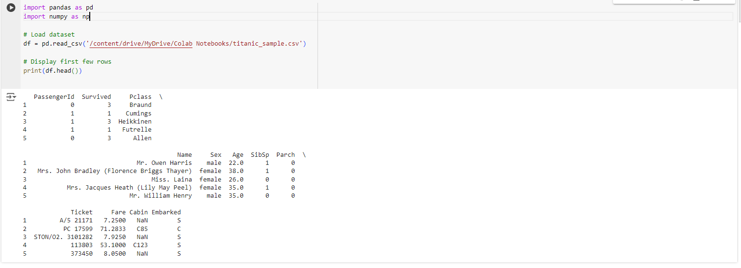  
 **Data Cleaning :Handle missing values, outliers, and duplicates.**

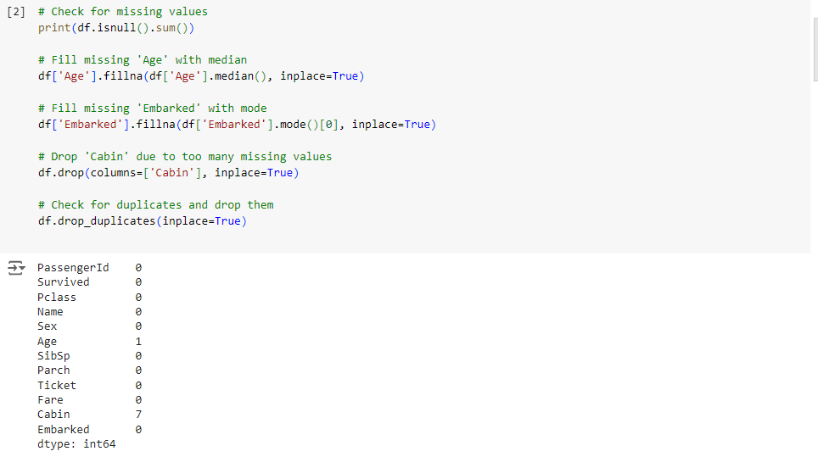

#### **Summary Statistics**

Summarize the dataset to understand its distribution

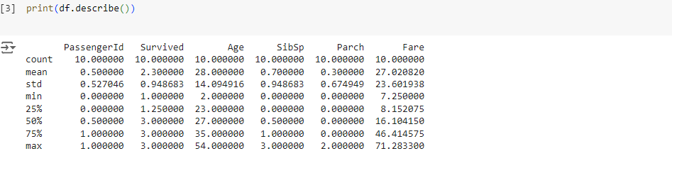

**Data Visualization and Discussion**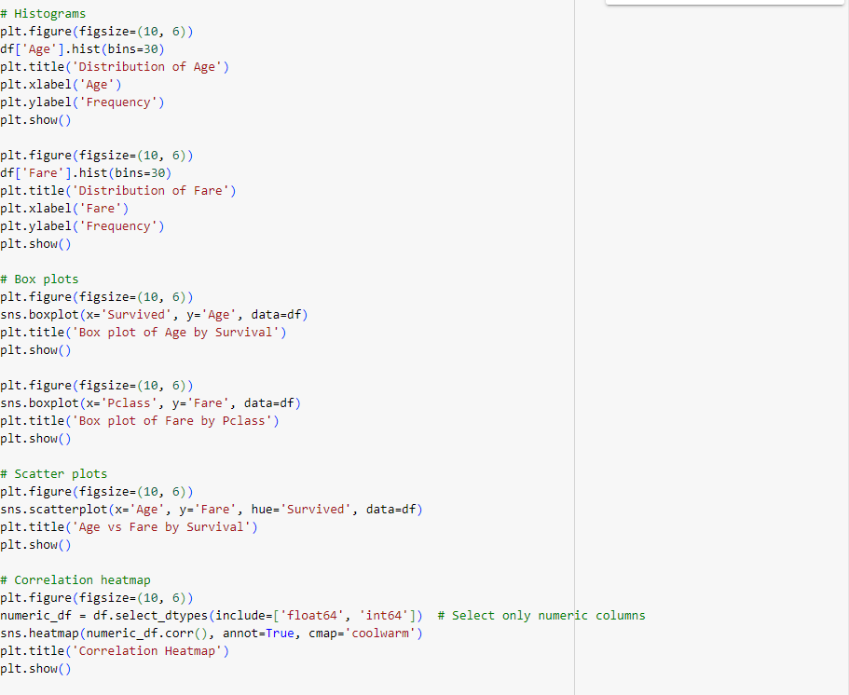

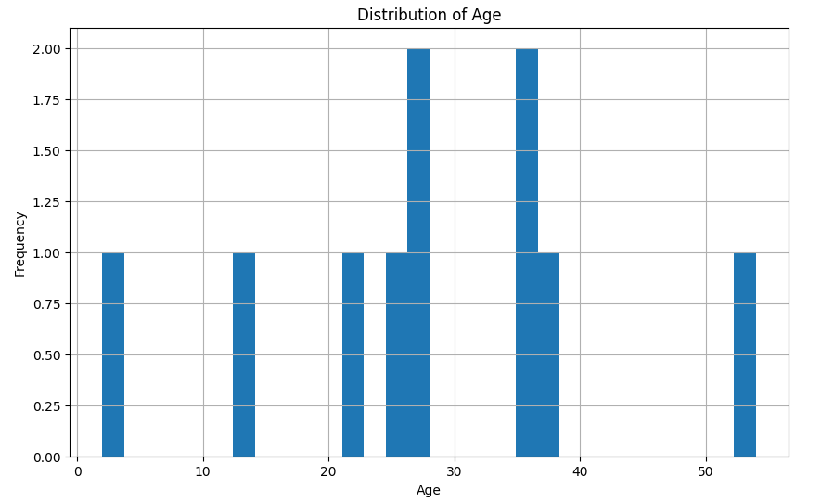

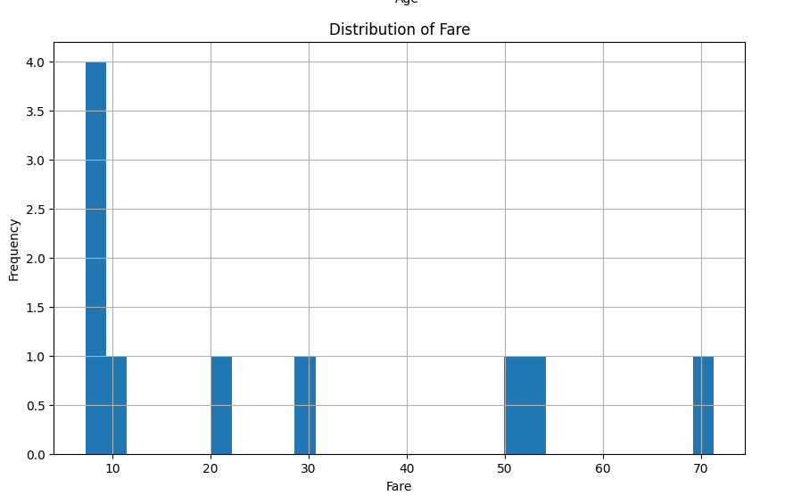

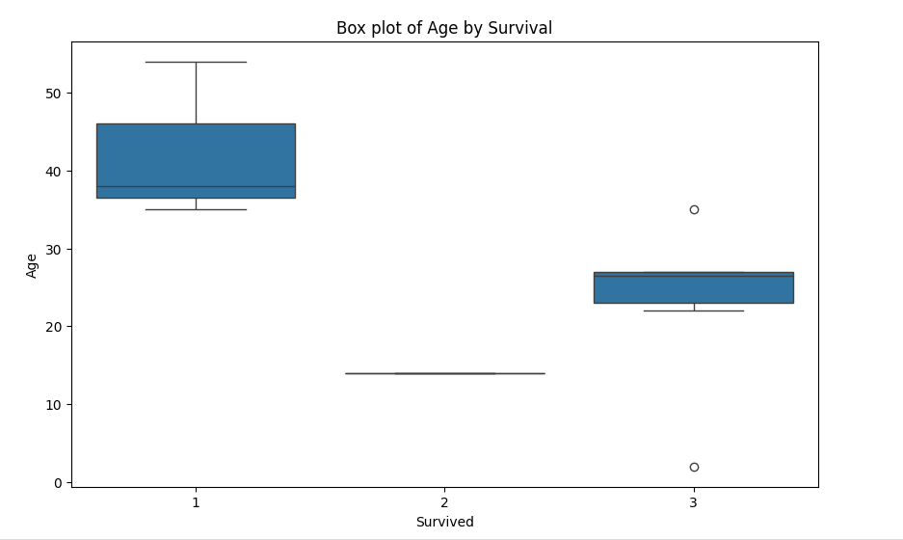

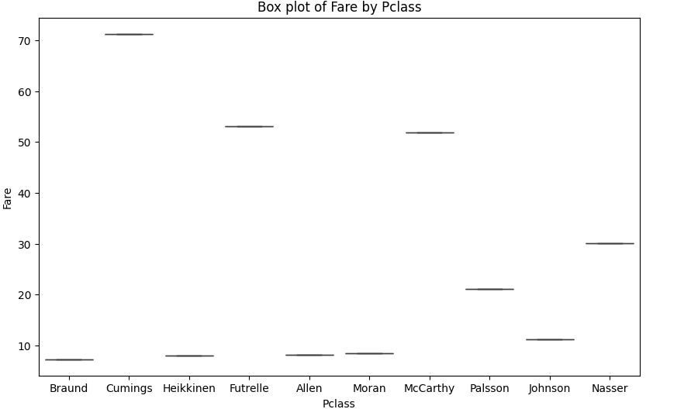

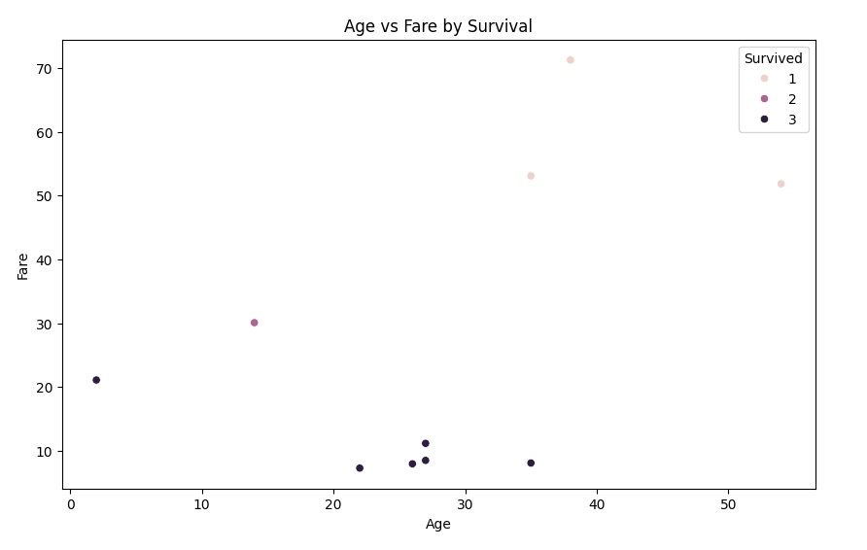

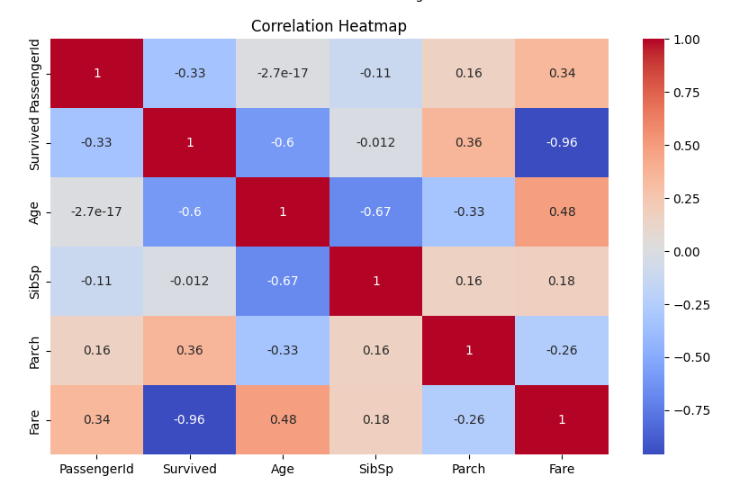

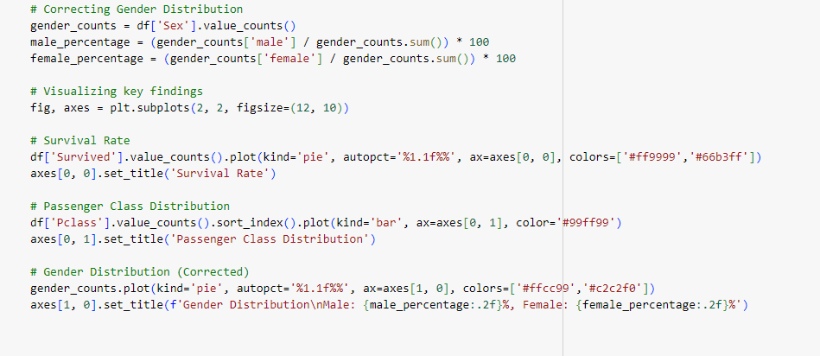

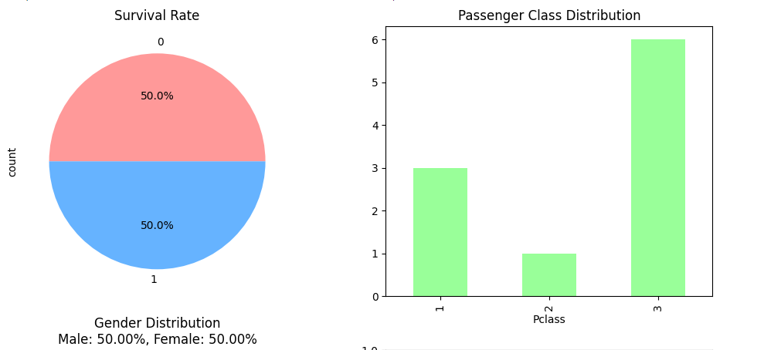

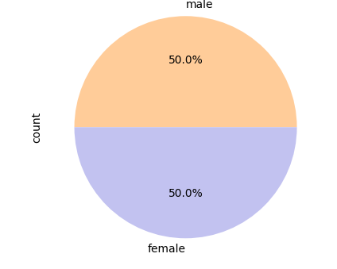

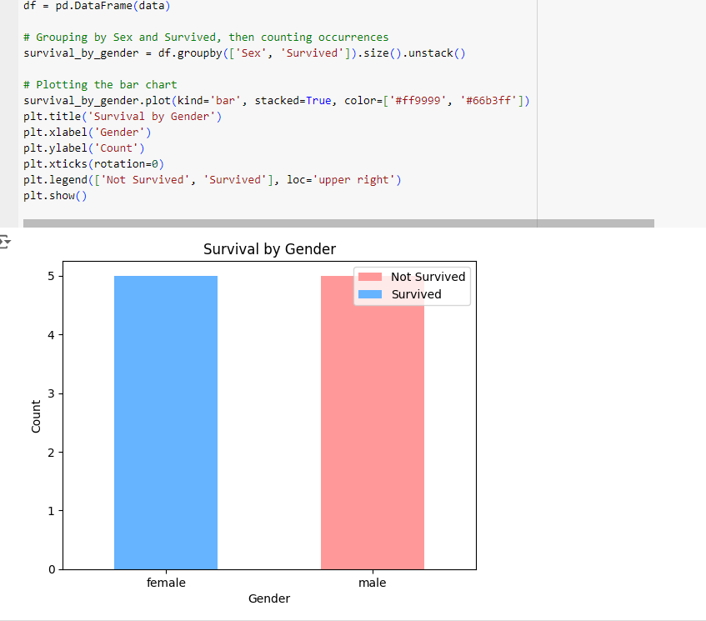

**Summarize key findings:**

* None of the male had survived.
* Passengers in 1st class had higher survival rates than those in 2nd and 3rd classes.
* Age Between 20-30 Survived most.

**Conclusion** : the Titanic dataset provides valuable insights into the dynamics of survival during the tragic event. Factors such as gender, passenger class, and age played significant roles in determining the likelihood of survival. Further analysis could delve deeper into these factors and their interactions to gain a more comprehensive understanding of the Titanic disaster and its impact on passengers.

References:https://www.kaggle.com/competitions/titanic